Hotel Reception Management System
Ali Awdallah
Abdulrahman Babkir
Diya Rafat

Part 2: Design and Threat Modeling
Hotel Reception Management System
1. Introduction
This part presents the design and threat modeling of the Hotel Reception Management System. The system is a desktop-based application developed using Java and JavaFX for hotel reception staff and managers. It is used to manage room reservations, guest check-ins and check-outs, billing, and service requests. The system stores data in a centralized database and includes security mechanisms such as authentication, role-based access control, audit logging, and backup procedures.
The main purpose of this part is to transform the requirements from Part 1 into a technical design, identify system components and data flows, and analyze the system from a security perspective. The system’s high-level functions include user authentication, room search, reservation management, check-in/check-out, payment recording, service request logging, and daily reporting for management.
2. Software Decomposition
The Hotel Reception Management System is divided into smaller modules to make development and security management easier. Based on the SRS, the design can be decomposed into the following layers and modules.
2.1 Presentation Layer
This layer contains the JavaFX graphical user interface. It includes the login screen, dashboard, room search screen, reservation screen, check-in/check-out screen, payment screen, service request screen, report screen, and security administration screens.
2.2 Business Logic Layer
This layer handles the main system processing. Its functions include:
- authentication and session handling
- role verification
- reservation creation, modification, and cancellation
- room availability validation
- check-in/check-out processing
- payment and invoice processing
- service request logging
- report generation
- audit logging
- backup and recovery coordination
2.3 Data Access Layer
This layer is responsible for reading and writing application data between the system and the database. It handles users, guests, rooms, reservations, payments, invoices, service requests, audit logs, and backup records.
2.4 Database Layer
This layer stores all persistent hotel data, including guest records, room details, reservation records, payments, service requests, and logs. The system stores and retrieves data from a centralized database and protects guest information and financial records.
2.5 Security Services Layer
This layer enforces the security controls required in the SRS, such as strong authentication, role-based access control, audit logging, reservation validation to prevent overlap, and backup/recovery.
3. UML Class Diagram
The UML class diagram models the static structure of the Hotel Reception Management System. It shows the main entities in the system and the relationships among them. The diagram includes User, Role, Guest, Room, Reservation, Payment, Invoice, ServiceRequest, AuditLog, and BackupRecord. These classes reflect the major operational and security functions in the system, such as authentication, reservation management, billing, service requests, logging, and backup.
3.1 Main Classes
- User stores system account information.
- Role defines authorization levels and permissions.
- Guest stores guest's personal and contact data.
- Room stores room information, type, and status.
- Reservation manages booking records and dates.
- Payment records guest payments.
- Invoice stores billing totals.
- ServiceRequest stores guest support requests.
- AuditLog stores security-related activity logs.
- BackupRecord stores backup metadata and verification details.
3.2 Relationships
The main relationships shown in the UML are:
- One role can be assigned to many users
- one user can manage many reservations
- One guest can have many reservations
- One room can appear in many reservations over time
- One reservation can have many payments
- One reservation has one invoice
- One guest can have many service requests
- One user can create many audit log entries
- One user can be associated with many backup records
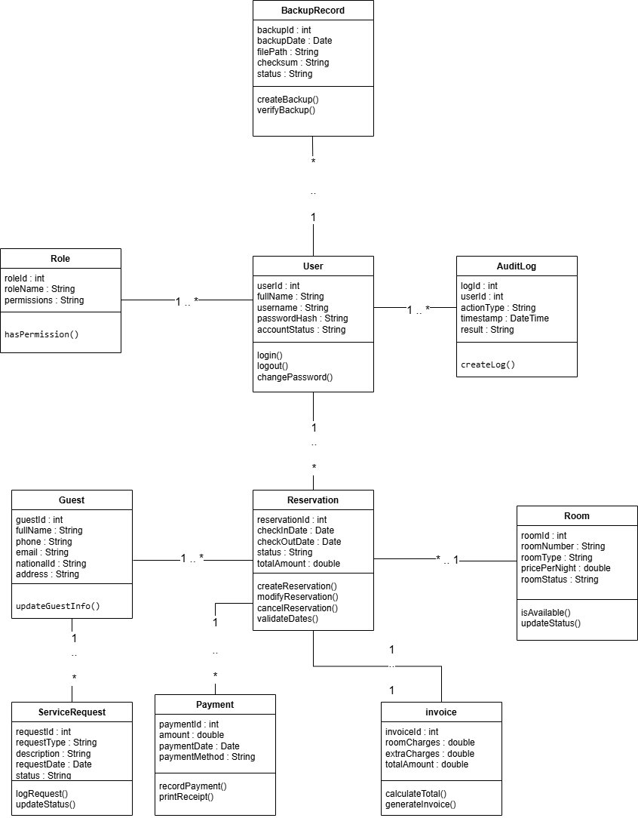Caption:
Figure 1: UML Class Diagram of the Hotel Reception Management System
4. External Entities and Entry Points
Since the system is a desktop application, the external entities are mainly users and connected system resources outside the application boundary.
4.1 External Entities
Receptionist
The receptionist is the primary operational user of the system. The receptionist logs in, searches for available rooms, creates and updates reservations, performs guest check-in and check-out, records payments, and logs service requests.
Manager
The manager accesses the system to review daily operational reports and summaries.
Admin
The admin is responsible for security and maintenance functions such as backup, and review of logs. While the system mainly focuses on receptionists and managers, the security requirements clearly imply an administrative role for maintaining backup and recovery and enforcing security controls.
Hotel Database
The hotel database stores operational and security-related records, including users, rooms, guests, reservations, payments, service requests, and audit logs.
Backup Storage
Backup storage is used to store backup files and support recovery after incidents such as malware or data loss.
Printer
The printer is used to print invoices, receipts, and reports.
4.2 Entry Points
The main system entry points are:
- login screen
- room search screen
- create reservation screen
- modify/cancel reservation screen
- check-in screen
- check-out screen
- payment screen
- service request screen
- report screen
- backup/recovery interface
- database connection interface
- local workstation access
These entry points are important because many threats begin through them, especially unauthorized login, reservation abuse, payment manipulation, data theft, and malware or ransomware infection.
5. Data Flow Diagrams
5.1 Context Diagram (Level 0 DFD)
The Level 0 DFD represents the entire Hotel Reservation System as one main process and shows how it exchanges data with external entities. The receptionist sends login data, reservation data, check-in/check-out data, payment data, and service request data to the system. The manager sends report requests and receives summaries and reports. The admin sends user-management, backup and log-review requests. The system also exchanges operational data with the hotel database, backup files with backup storage, and print jobs with the printer.
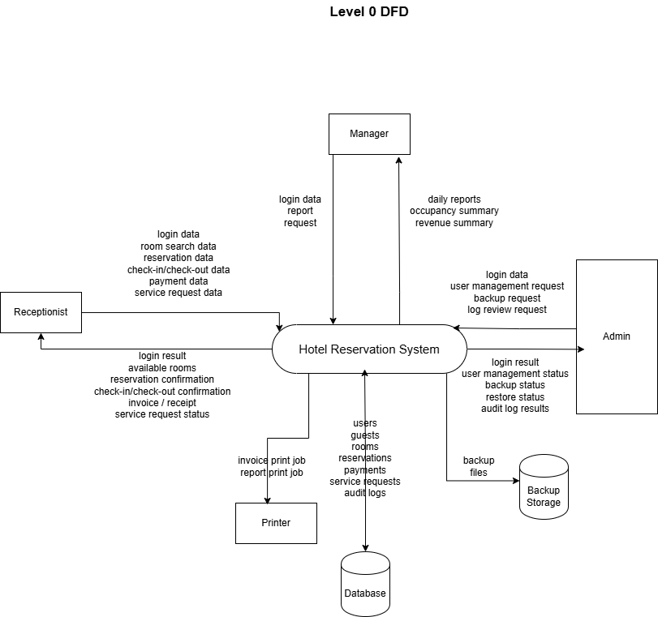Caption:
Figure 2: Level 0 Data Flow Diagram of the Hotel Reception Management System
5.2 Level 1 DFD
The Level 1 DFD decomposes the system into the following major processes:
- P1 Authenticate User
- P2 Manage Reservations
- P3 Check-In / Check-Out
- P4 Manage Payments and Billing
- P5 Log Service Requests
- P6 Generate Reports
- P7 Audit and Backup Management
The main data stores are:
- D1 Users
- D2 Guests
- D3 Rooms
- D4 Reservations
- D5 Payments
- D6 Service Requests
- D7 Audit Logs
- D8 Backups
This decomposition matches the functional and security requirements identified in the SRS.
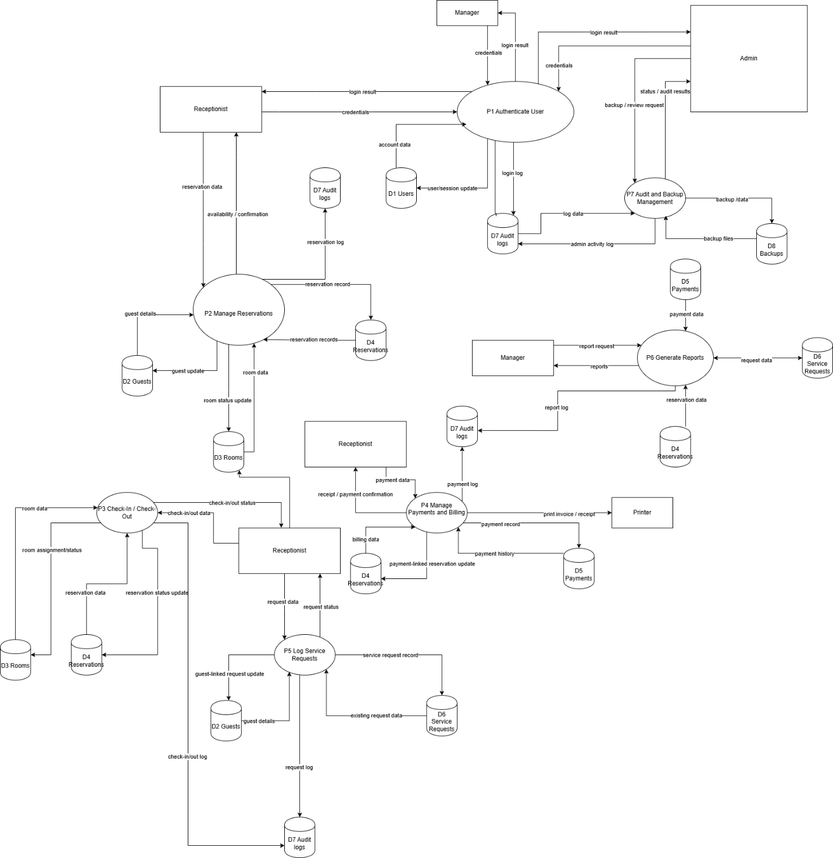Caption:
Figure 3: Level 1 Data Flow Diagram of the Hotel Reception Management System
Note: Some entities and data stores are duplicated in the Level 1 DFD only to improve readability and reduce complexity. The duplicates represent the same original components.

6. Threat Modeling Using STRIDE
The STRIDE methodology is used to identify the main threats against the system. STRIDE stands for Spoofing, Tampering, Repudiation, Information Disclosure, Denial of Service, and Elevation of Privilege. This model is suitable because the system already includes abuse cases involving unauthorized login, double-booking, payment manipulation, guest data theft, and malware or ransomware.
6.1 STRIDE Threat Table
Threat ID | Threat | STRIDE Category | Target Component | Description | Mitigation
T1 | Unauthorized login | Spoofing | Login process, user accounts | An attacker uses stolen or guessed credentials to access the system. | Strong authentication, account lockout, and logging
T2 | Double-booking | Tampering | Reservation module | Overlapping reservations are created for the same room. | Reservation validation and overlap checks
T3 | Payment manipulation | Tampering | Billing module | A user changes invoice or payment values to commit fraud. | RBAC, audit logs, approval for edits
T4 | User denies actions | Repudiation | Reservation/payment/report actions | A user denies having performed a sensitive action. | Protected audit logging
T5 | Guest data theft | Information Disclosure | Guest records, reports | The guest's personal data is viewed or exported without authorization. | RBAC, monitored access, restricted export
T6 | Financial data leakage | Information Disclosure | Payments, invoices, reports | Confidential financial data becomes visible to unauthorized users. | Role-based restrictions
T7 | Service interruption | Denial of Service | Desktop app, database access | The system becomes unavailable, and staff cannot perform operations. | Recovery procedures, stable error handling
T8 | Malware/ransomware | Denial of Service / Tampering / Information Disclosure | Workstations, database, files | Malware encrypts or corrupts system data. | Backup/recovery, endpoint protection
T9 | Privilege escalation | Elevation of Privilege | Admin/manager-only features | A lower-level user gains access to protected functions. | RBAC and protected authorization
T10 | Audit log manipulation | Tampering / Repudiation | Audit logging store | A malicious user edits or deletes evidence of activity. | Tamper-resistant audit logs

6.2 STRIDE Discussion
These threats are grounded in the abuse cases and security requirements from the SRS. For example:
- unauthorized login maps to abuse case A001
- double-booking maps to A002
- payment manipulation maps to A003
- guest data theft maps to A004
- malware or ransomware maps to A005
The chosen mitigations also reflect the security requirements, such as strong authentication, role-based access control, audit logging, overlap validation, and backup/recovery.
7. DREAD Risk Rating
The DREAD model is used to rate the identified threats based on:
- Damage Potential
- Reproducibility
- Exploitability
- Affected Users
- Discoverability
Each factor is rated from 1 to 10. The average score is then used to classify the threat risk level.

7.1 DREAD Table
Threat | Damage | Reproducibility | Exploitability | Affected Users | Discoverability | Average | Risk
Unauthorized login | 9 | 8 | 7 | 8 | 8 | 8.0 | High
Double-booking | 7 | 9 | 7 | 8 | 8 | 7.8 | High
Payment manipulation | 9 | 7 | 6 | 7 | 6 | 7.0 | High
Repudiation of actions | 6 | 8 | 7 | 6 | 7 | 6.8 | Medium
Guest data theft | 9 | 7 | 6 | 9 | 7 | 7.6 | High
Financial data leakage | 8 | 7 | 6 | 8 | 6 | 7.0 | High
Service interruption | 8 | 7 | 6 | 9 | 6 | 7.2 | High
Malware/ransomware | 10 | 7 | 6 | 10 | 7 | 8.0 | High
Privilege escalation | 10 | 6 | 6 | 9 | 6 | 7.4 | High
Audit log manipulation | 7 | 6 | 5 | 7 | 5 | 6.0 | Medium
7.2 DREAD Discussion
The highest-risk threats are unauthorized login, malware or ransomware, privilege escalation, guest data theft, and double-booking. These threats have a direct effect on the confidentiality, integrity, and availability of the system.
8. Threat Documentation
T1 – Unauthorized Login
- Threat ID: T1
- Category: Spoofing
- Target: Login screen and staff accounts
- Description: An attacker attempts to authenticate using stolen, guessed, or brute-forced credentials.
- Entry Point: Login screen
- Impact: Unauthorized access to reservations, payments, reports, and guest information
- Mitigation: Strong authentication, account lockout, optional second factor, audit logging
T2 – Double-Booking
- Threat ID: T2
- Category: Tampering
- Target: Reservation creation and modification
- Description: A malicious or compromised staff account creates overlapping bookings for the same room and date range.
- Entry Point: Create a reservation and modify the reservation screens
- Impact: Operational confusion, guest dissatisfaction, possible fraud
- Mitigation: Validate reservation dates and block overlaps
T3 – Payment Manipulation
- Threat ID: T3
- Category: Tampering
- Target: Payment and invoice functionality
- Description: A user alters payments, charges, or invoice totals to reduce balances or hide fraud.
- Entry Point: Payment recording and invoice interfaces
- Impact: Financial loss and inaccurate reporting
- Mitigation: Role-based control, audit logging, managerial approval for sensitive changes
T4 – Repudiation of Sensitive Actions
- Threat ID: T4
- Category: Repudiation
- Target: Reservation, payment, and reporting actions
- Description: A user denies performing a cancellation, modification, or financial action.
- Entry Point: Any operational screen handling sensitive actions
- Impact: Weak accountability and investigation difficulty
- Mitigation: Protected audit logs with timestamp, user ID, and action type
T5 – Guest Data Theft
- Threat ID: T5
- Category: Information Disclosure
- Target: Guest records, reservation details, reports
- Description: A malicious insider or attacker exports contact details, ID or passport data, and stay history.
- Entry Point: Guest profile, search, reporting, export screens
- Impact: Privacy violations, identity theft, possible legal and business consequences
- Mitigation: RBAC, restricted access, monitored logs
T6 – Financial Data Disclosure
- Threat ID: T6
- Category: Information Disclosure
- Target: Payment records, invoices, revenue reports
- Description: Unauthorized access to sensitive billing or revenue data.
- Entry Point: Payment screens and report screens
- Impact: Confidentiality breach and business risk
- Mitigation: Role-based access and restricted reporting
T7 – Service Interruption
- Threat ID: T7
- Category: Denial of Service
- Target: Application and database availability
- Description: The system becomes partially or fully unavailable due to crashes, excessive failures, or other disruptions.
- Entry Point: Workstation, application runtime, data access layer
- Impact: Staff cannot perform front-desk operations
- Mitigation: Backup/recovery, stable error handling, monitoring
T8 – Malware / Ransomware
- Threat ID: T8
- Category: Denial of Service / Tampering / Information Disclosure
- Target: Workstations, reservation database, financial data
- Description: Malware encrypts, corrupts, or leaks system data and disrupts operation.
- Entry Point: Infected USB devices, malicious attachments, compromised browsing
- Impact: Downtime, data loss, privacy breach
- Mitigation: Verified backups, capability, protected endpoints
T9 – Privilege Escalation
- Threat ID: T9
- Category: Elevation of Privilege
- Target: Manager-only and admin-only functions
- Description: A lower-level user gains access to protected features such as reporting or security management.
- Entry Point: Menu screens and protected operations
- Impact: Unauthorized control over sensitive data or settings
- Mitigation: Role-based access control and protected authorization checks
T10 – Audit Log Manipulation
- Threat ID: T10
- Category: Tampering / Repudiation
- Target: Audit log storage
- Description: A malicious user edits or deletes audit entries to hide suspicious activity.
- Entry Point: Log store or privileged maintenance features
- Impact: Loss of evidence and reduced traceability
- Mitigation: Protected, tamper-resistant audit logging

9. Security Design Decisions
The design of the Hotel Reception Management System includes the following security decisions:
- Authentication is mandatory before system access.
All users must log in before using any function in the system.
- Role-based access control is enforced.
Receptionists, managers, and admins should only access the functions allowed for their roles.
- Sensitive actions must always be logged.
This includes login attempts, reservation changes, payment changes, report access, and backup activities.
- Reservation validation prevents overlap.
The system must validate room booking dates to prevent double-booking.
- Backup and recovery are required.
The system must support backup creation operations to recover from failures or attacks.
- Guest and financial information are treated as sensitive data.
Access to these records must be restricted and monitored.
10. Conclusion
In this part, the Hotel Reception Management System was designed with security considerations. The software was decomposed into logical modules, and the main external entities and entry points were identified. The system’s data movement was represented using the Level 0 and Level 1 DFDs, while the UML class diagram modeled the static structure of the system.
A STRIDE-based threat model was then used to identify important security risks such as unauthorized login, double-booking, payment manipulation, guest data theft, and malware or ransomware. These threats were then prioritized using the DREAD model, and suitable mitigations were selected. This shows that security must be considered during the design phase from the beginning rather than being added later.

